

**GAMER CORNER WEBSITE**

Group 2

Written by :

Fikhri Maheswara Taswandi

Layalia Hasya

Faculty :

**MR. REZA MAULANA, S.kom, M.kom**

Class :

3WD1

**CEP CCIT**

**FAKULTAS TEKNIK UNIVERSITAS INDONESIA**

**2024**

**PROJECT ON**

*Gamer Corner website*

**Developed by**

1. **Fikhri Maheswara Taswandi**
2. **Layalia Hasya**



**Gaming Corner website**

Batch Code : 3WD1

Start Date : 13th September 2024   
End Date : 30th September 2024

Name of Faculty : MR. REZA MAULANA, S.kom, M.kom

Names of Developer :

1. Fikhri Maheswara Taswandi
2. Layalia Hasya

Date of Submission: 30th September 2024



**CERTIFICATE**

This is to certify that this report titled “Gamer Corner Website” embodies the original work done by Fikhri Maheswara Taswandi and Layalia Hasya. Project in partial fulfillment of their course requirement at NIIT.

Coordinator:

MR. REZA MAULANA, S.kom, M.kom

Thank you, the writers wish to Allah SWT, the Almighty God for His blessings and mercy, that we can complete this Project 1 task, both in the form of paper and in the form of presentations in a timely manner.

Thank you especially for faculty, MR. REZA MAULANA, and other faculty who always help. Thank you to the fellow friends who have supported, and also thank you for being a partner in this education at CCIT-FTUI.

Project 1 paper entitled “Gamer Corner Website” which we proposed as a requirement for the Project 1 assignment.

We realize that in the preparation and writing, there are still many mistakes. Therefore, we apologize for the errors and imperfections that readers find in this paper. We also hope for criticism and suggestions from readers if they find errors in this paper.

Finally, we hope that this paper that we have compiled can add insight to readers in general and writers in particular. Hopefully, this report can be useful for other writers and for the readers.

**SYSTEM ANALYSIS**

**System Summary:** For project 1 in semester 2, we initiated to create an online flight ticket booking program using the Java programming language. This program is often used and needed by tour and travel agents. The program we created is not only for booking flight tickets, but can also be used to view the number of tickets sold, ticket buyer data along with financial reports that can be accessed by the Manager. In conclusion, by using the Java programming language, a flight ticket booking system can be created easily and efficiently. This system provides a more comfortable experience for both reception staff and managers in managing orders and transactions made.

**ACKNOWLEDGEMENT**

**BACKGROUND**

Websites are widely used by people today for various reasons. It could be access to information.Websites provide easy access to information on a wide range of topics, from news and education to entertainment and shopping. Convenience. People can shop online, pay bills, book tickets, and perform many other tasks from the comfort of their homes.

Communication. Websites facilitate communication through email, social media platforms, and forums, connecting people from all over the world. Entertainment. People use websites to stream videos, listen to music, play games, and read articles for entertainment. Learning and Education. Educational websites offer courses, tutorials, and resources to learn new skills and gain knowledge.

Social interactions and social media websites allow people to stay connected with friends and family, share news, and meet new people. Business and Work. Websites are essential for remote work, online meetings, collaboration, and conducting business transactions. Health and Wellness. Health websites provide information about medical conditions, fitness tips, and health services.

Shopping or e-commerce websites allow people to purchase products and services online, often with a wider selection and at cheaper prices than in physical stores. Banking and finance, or online banking websites, allow people to manage their finances, pay bills, and make transactions easily and securely.

Overall, websites are used because they offer convenience, access to information, communication, and various services that make everyday tasks easier and more efficient.

**SYSTEM ANALYSIS**

**PROJECT 4**

HTML Project Name : “Food Recipes Website”

**Hardware :** Laptop Lenovo Ideapad Flex 14|AU7

Laptop AMD Ryzen 5

**Operating System :** Windows 11 Home Single Language

**Software :** Microsoft Word 2019

Canva

Visual Studio Code

Github & Git Bash (for collaboration)

https://github.com/TypicalTechGuy/TypicalTechGuy.github.io/tree/main/pages

|  |  |
| --- | --- |
| **Date** | **Activities** |
| 12th September 2024 | Decided on the project Name |
| 15th September 2024 | Started the project main page |
| 17th September 2024 | Started coding the website front page |
| 21stSeptember 2024 | Started coding the login and sign in |
| 26thSeptember 2024 | Started coding the article page |
| 30th September 2024 | Make papers and power point |

**CONFIGURATION**

Gaming Corner Website has nine web pages (include sign in and sign up page) that can be accessed by user via the navigation bar, that is Home page, news/blog page, type of news (Trending, Console, PC, Retro, Arcade), Profile, sign in and sign up page. Each user on the Gaming Corner Website can access all the pages in the Gaming Corner Website and also can click the sign in and sign up button if the user has not been registered with Gaming Corner Website.

The contents of each website pages are:

**1. Sign in and Sign up page**

Sign in and sign up pages are for the admin to manage all contents in the Gaming Corner website.

**2. Home page**

Home page contains a navigation bar to open a different pages on the website. In the navigation bar there are also button to sign in and sign up. Then, there is a search section that can be used by user to search any kinds of news in the Gaming Corner Website. We also provide a trending news flash so the user can see what’s trending/hype in the gaming world that available in Gaming Corner Website. There is also a button in each section to go to the different page so user can see many News on there.

**3. Type of News**

Type on news page contains a news from each type, there are:

• **Trending :** This page contains a news that include to the type of hype or trending news that is trending these days.

• **Console :** This page contains a news that include to the type of news that are hype or trending in the Console games.

• **PC :** This page contains a news that include to the type of news that are hype or trending in the PC Games.

• **Retro :** This page contains a news that include to the type of news that are hype or trending in the Retro games.

• **Arcade :** This page contains a news that include to the type of news that are hype or trending in the Arcade games.

**4. Profile**

This page contain all data of the users profile where they can upload photo’s as their profile and edit their profile or data to their desire.

**INTRODUCTION**

* **Home Page**

There is the navigation bar section in the home page to go to the different page in the website. And after that, there is a search section that can be used by user to search any type of news in Gaming Corner Website. And each time our cursor hover one of the news, it’ll widen or zoom in slightly on the news our cursor are hovering.

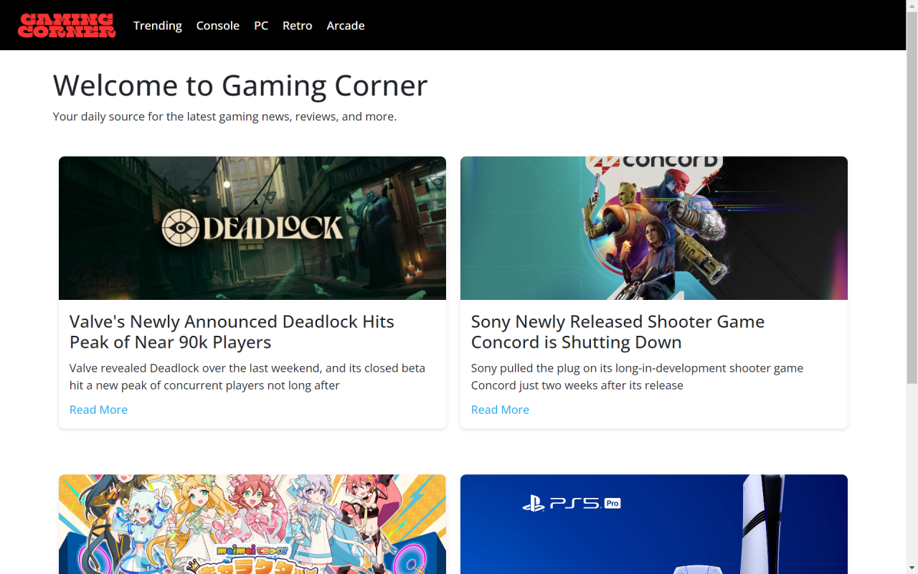

* **Home Page**

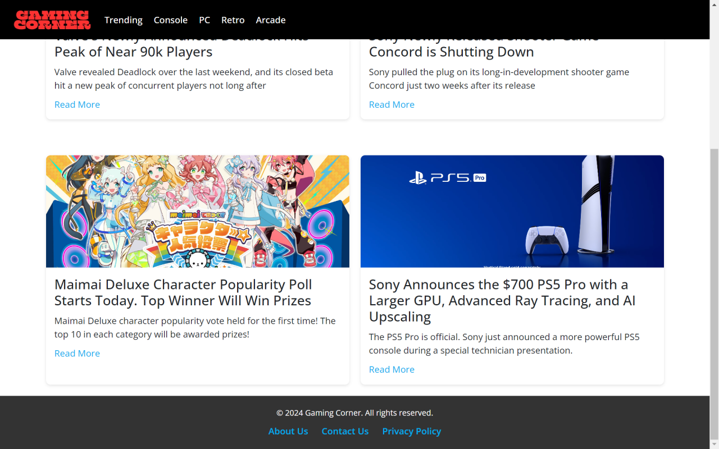

**WEBSITE PAGES (HOME PAGE)**

* **Trending Page**

In this page, we will see all types of Trending news about games that are popular or hype in today’s algorithm.

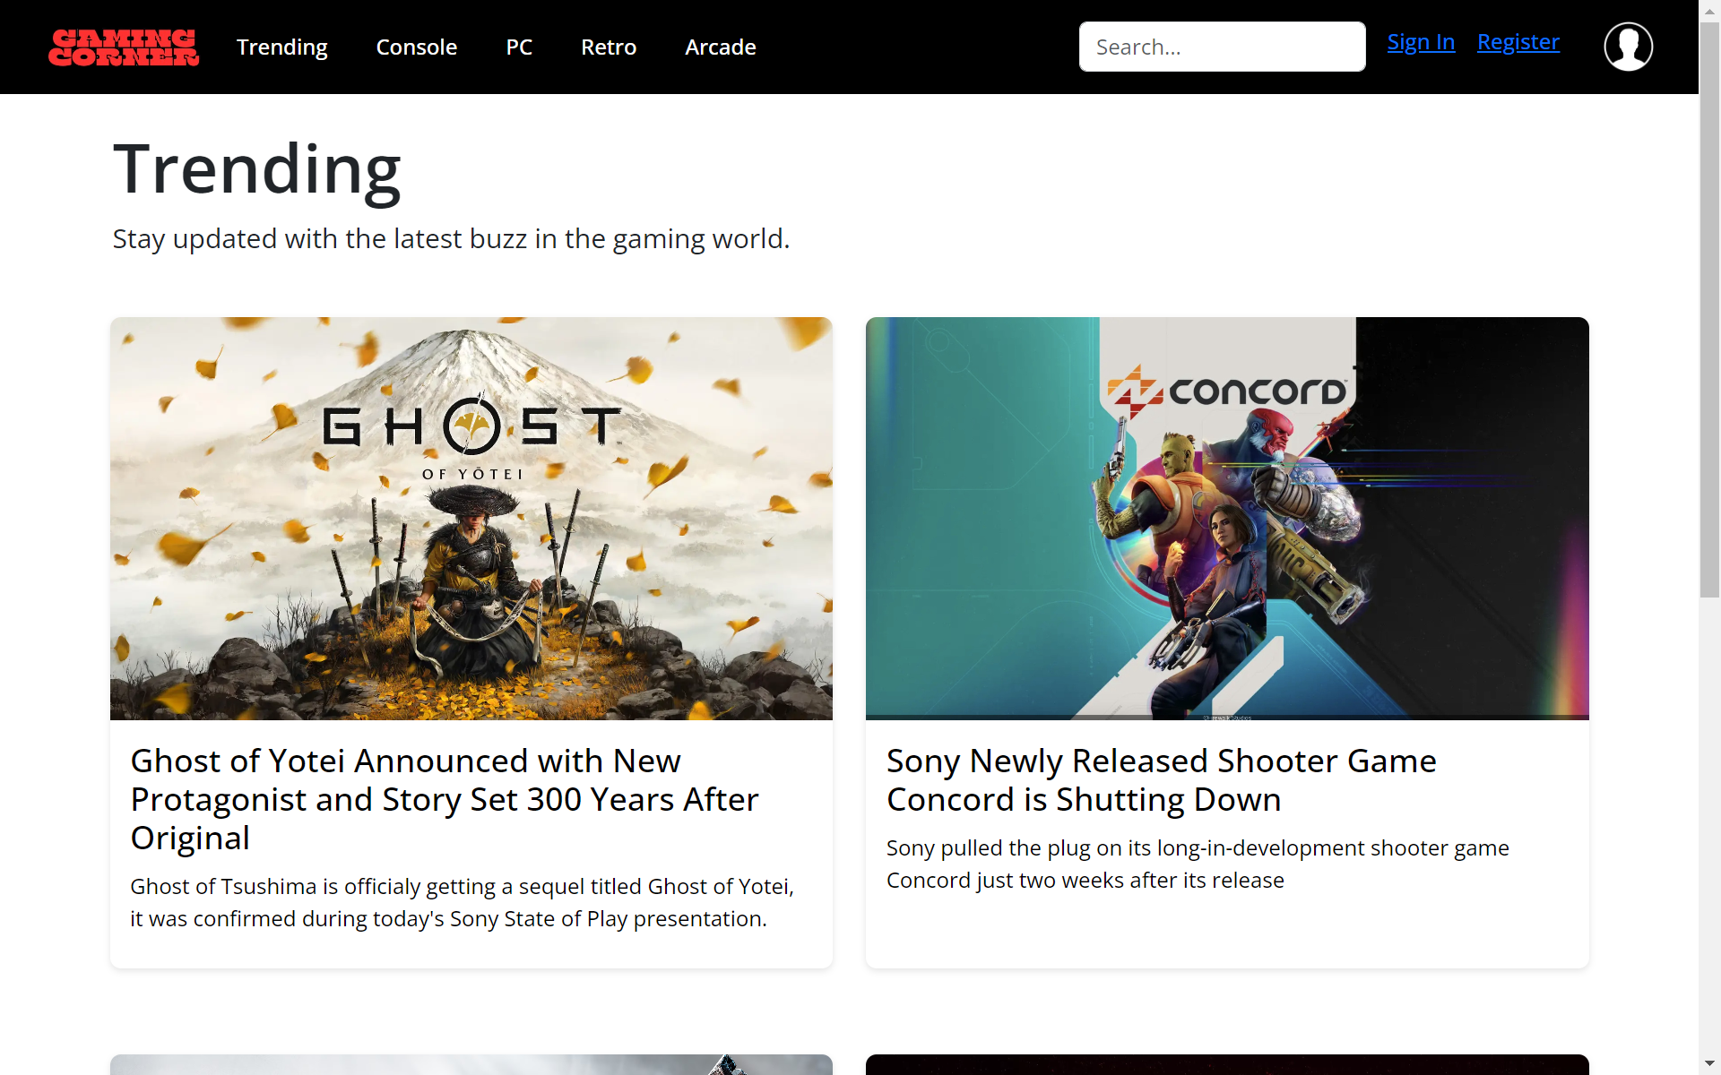

At the bottom, we will see a button to slide to the next news that is on the trending list.

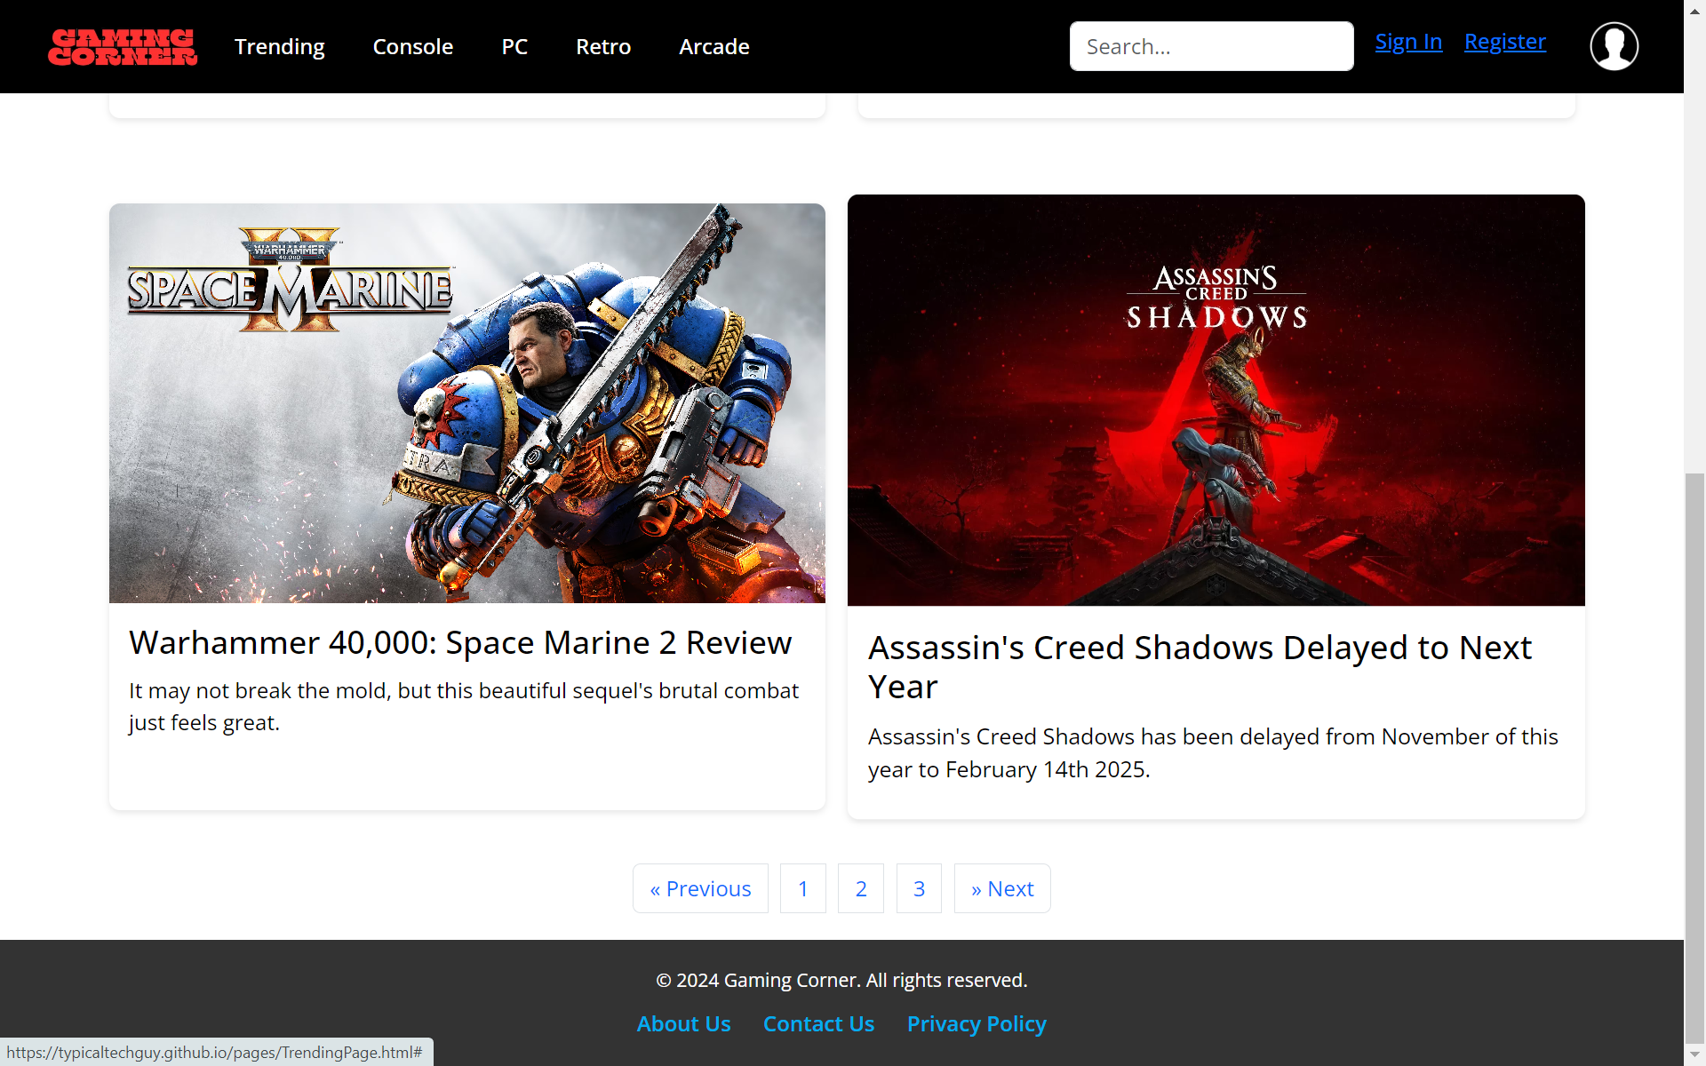

**WEBSITE PAGES (TRENDING)**

* **Console Page**

In this page, we will see all types of Trending news about console games that are popular or hype in today’s algorithm.

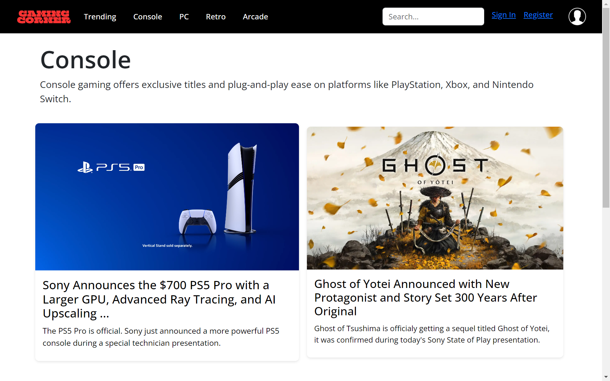

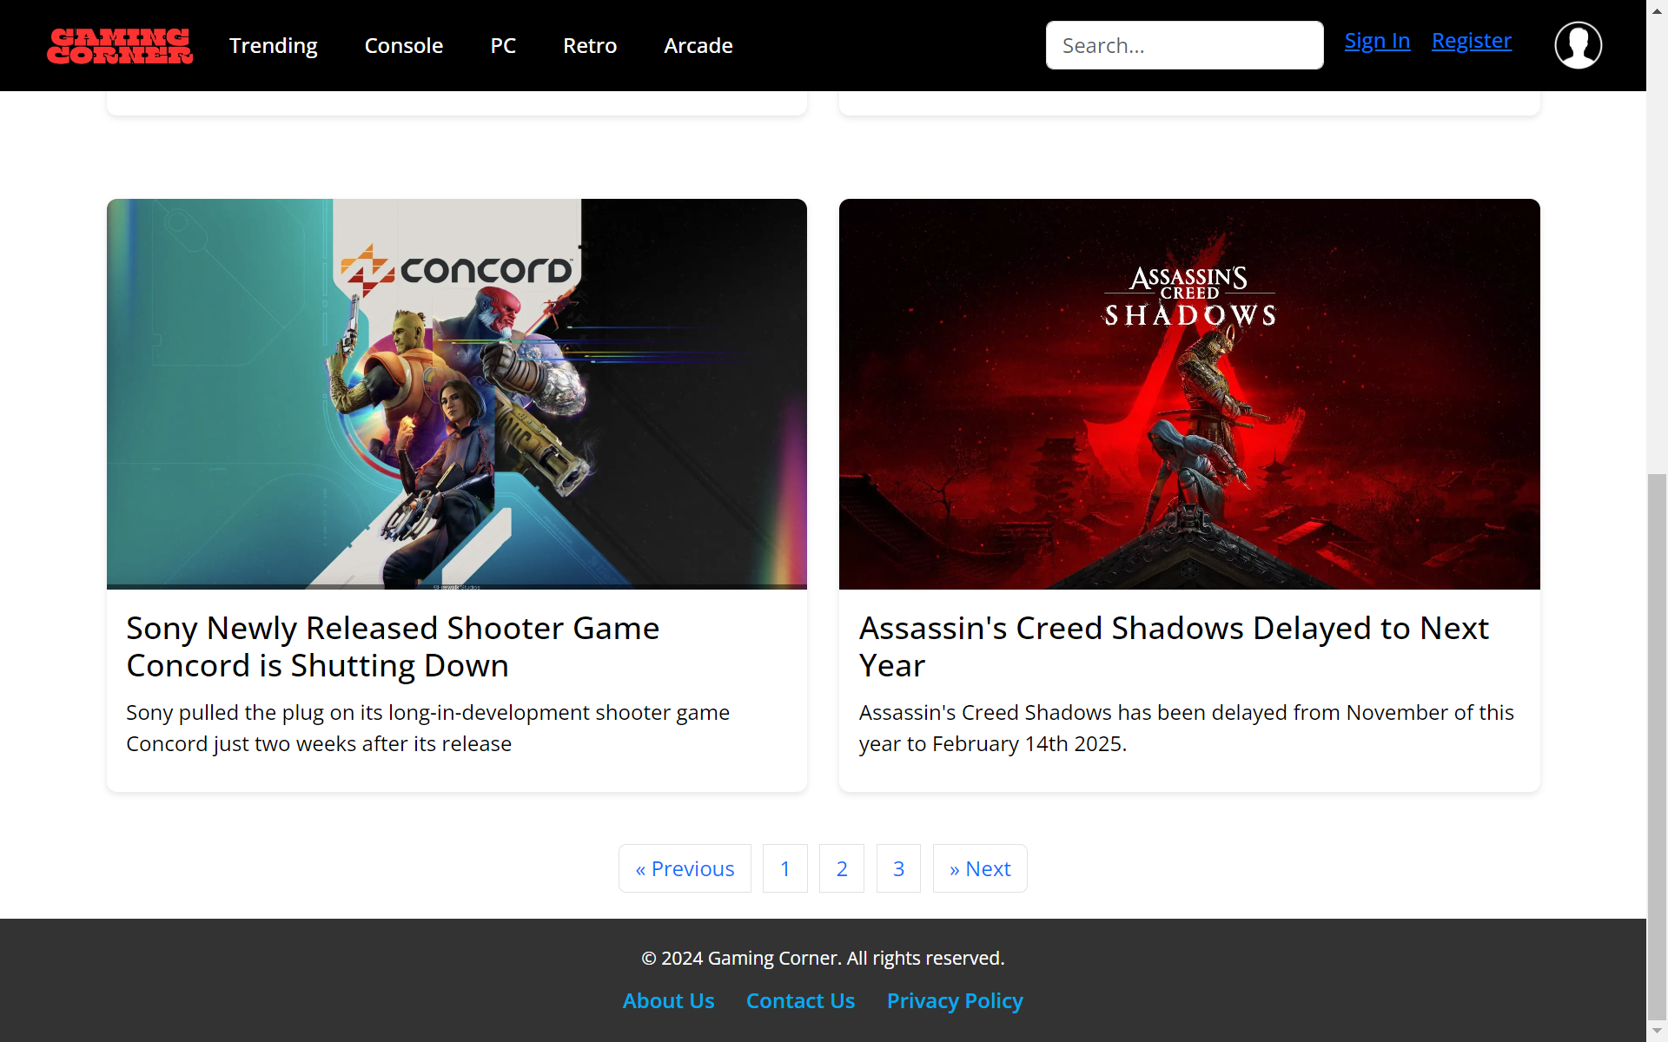

**WEBSITE PAGES (CONSOLE)**

* **Console Page**

In this page, we will see all types of Trending news about pc games that are popular or hype in today’s algorithm.

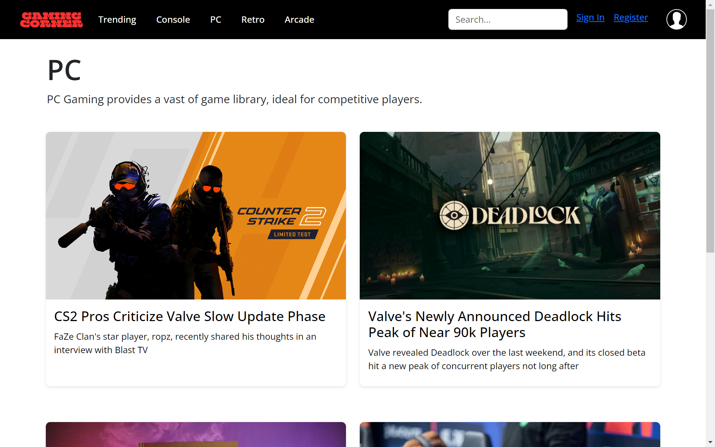

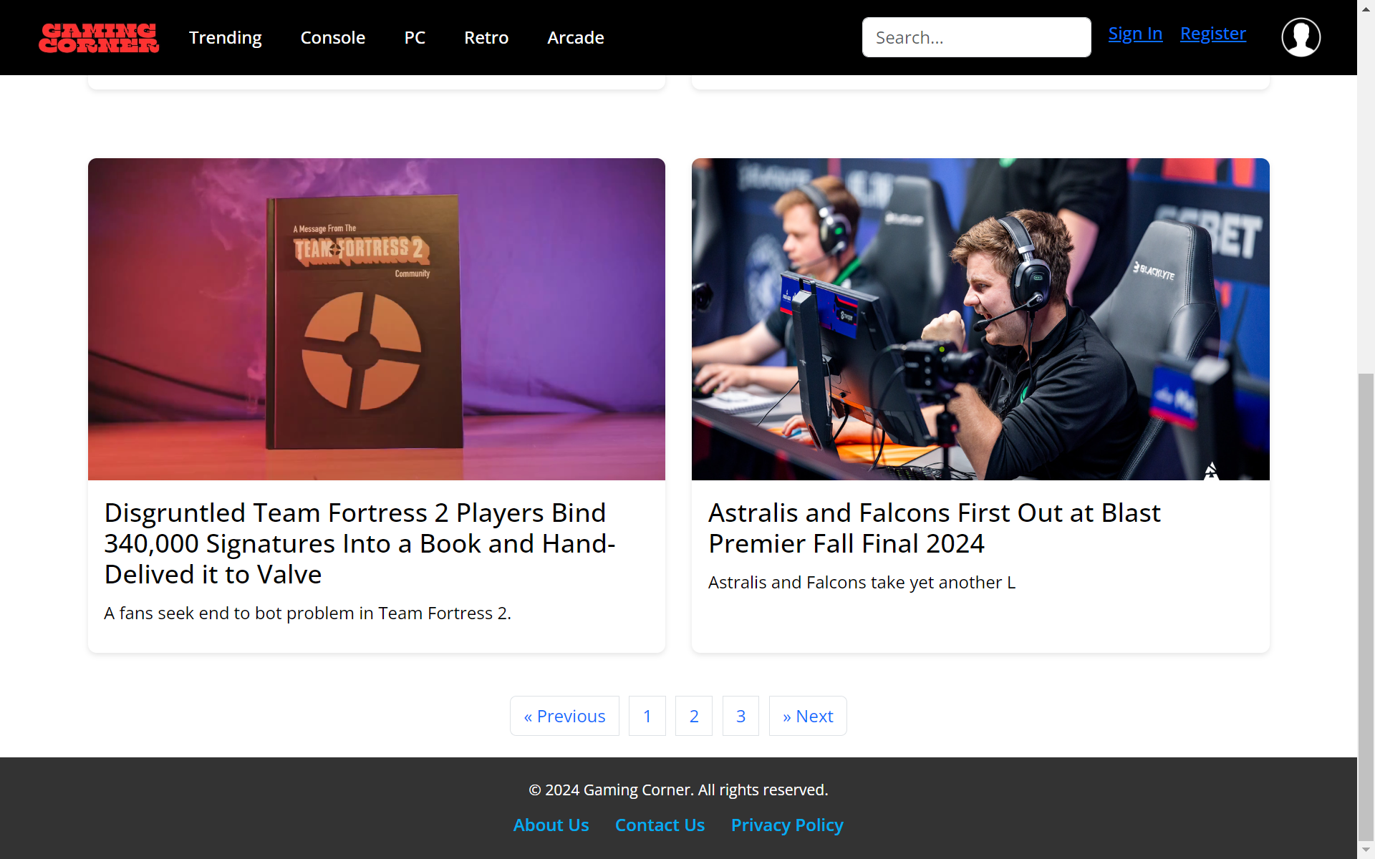

**WEBSITE PAGES (PC)**

* **Retro Page**

In this page, we will see all types of Trending news about retro games that are popular or hype in today’s algorithm.

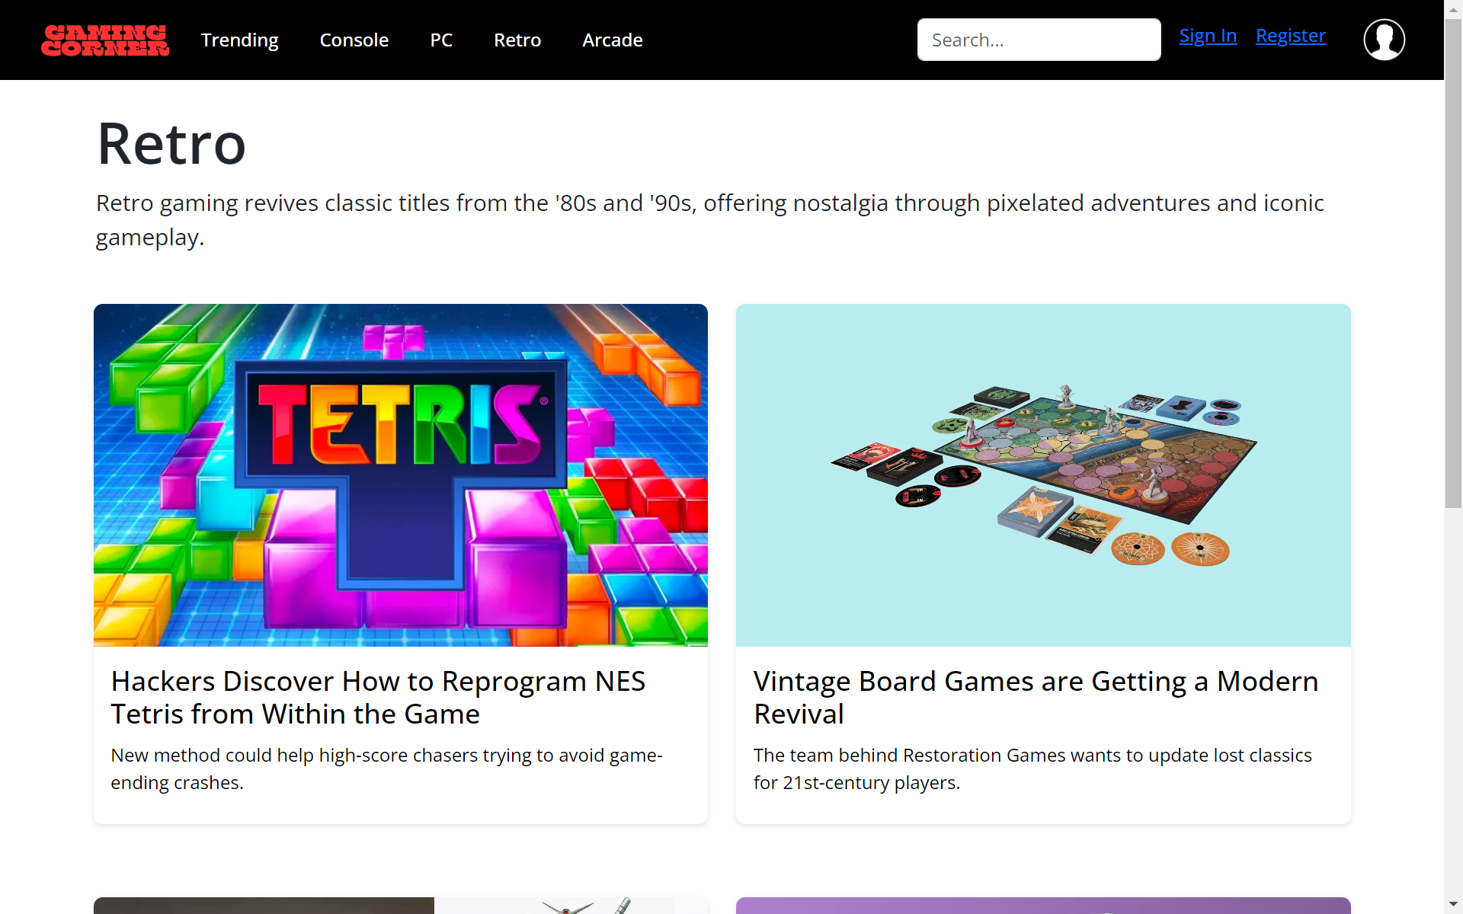

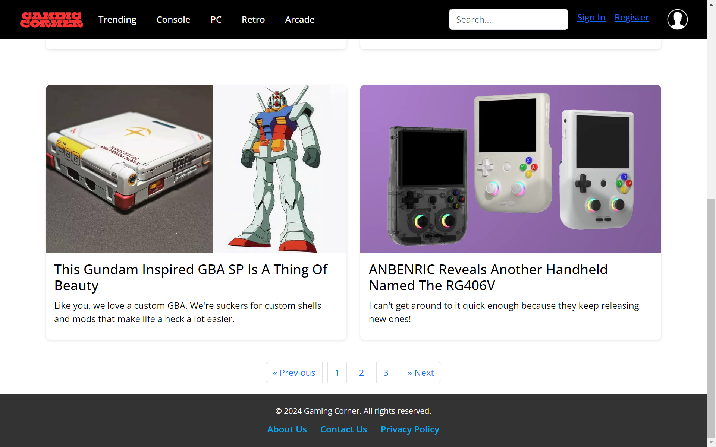

**WEBSITE PAGES (RETRO)**

* **Arcade Page**

In this page, we will see all types of Trending news about arcade games that are popular or hype in today’s algorithm.

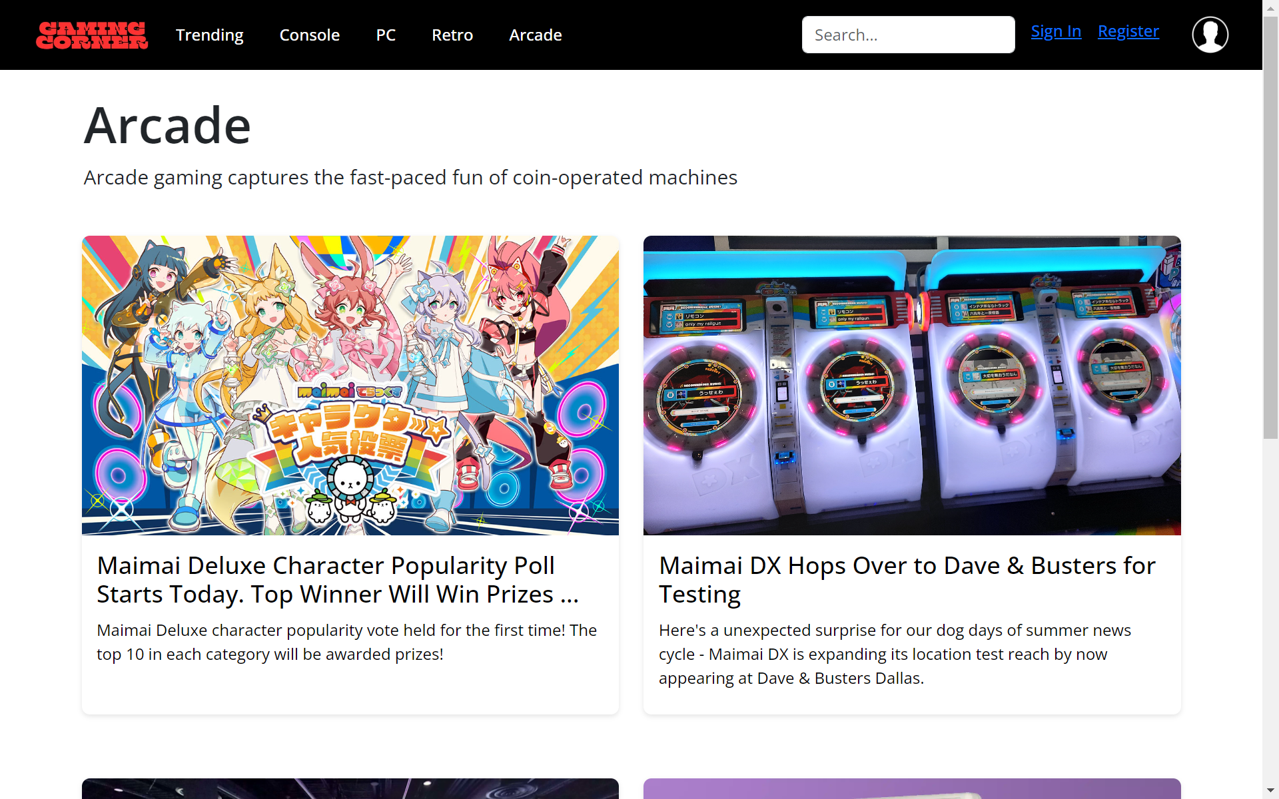

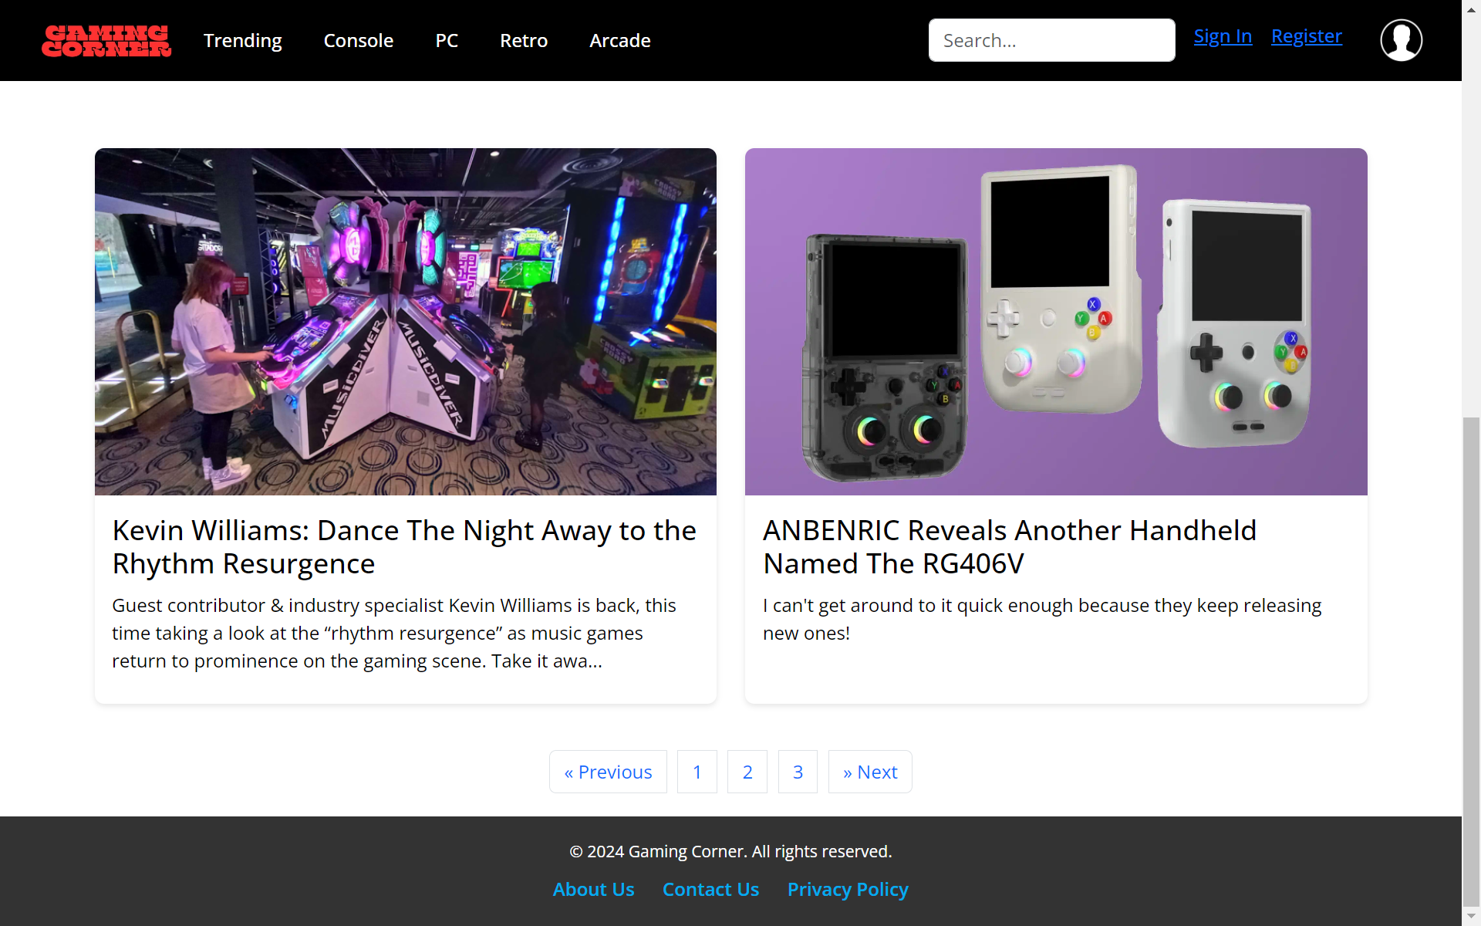

**WEBSITE PAGES (ARCADE)**

* **News blog Page**

When we clicked one of the blog news, we will immediately see the contain of the news we picked.

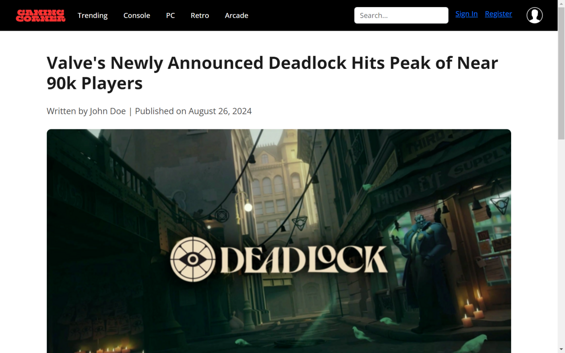

In here, we can see all the information or news that the blog has to offer.

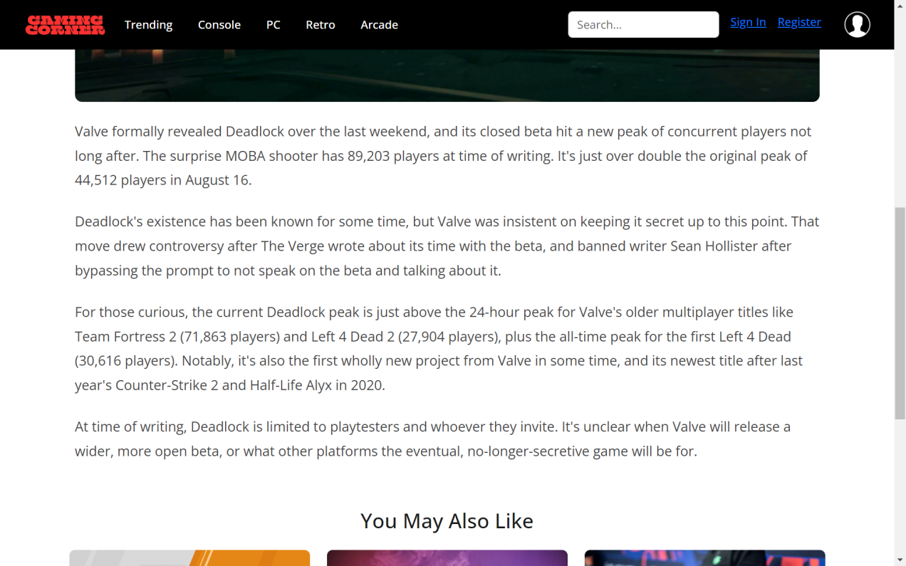

**WEBSITE PAGES (NEWS BLOG)**

* **News Blog Page**

And then lastly, at the very bottom of the news, we will be offered with what news we may also like to read after the first blog.

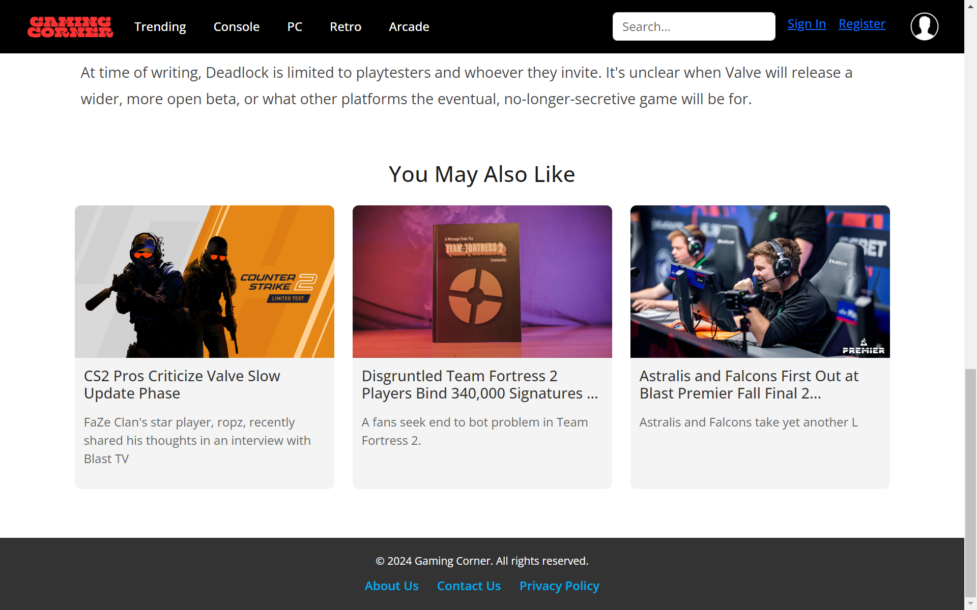

**WEBSITE PAGES (NEWS BLOG)**

* **Sign In Page**

In this page, we will input our data to sign in to the website.

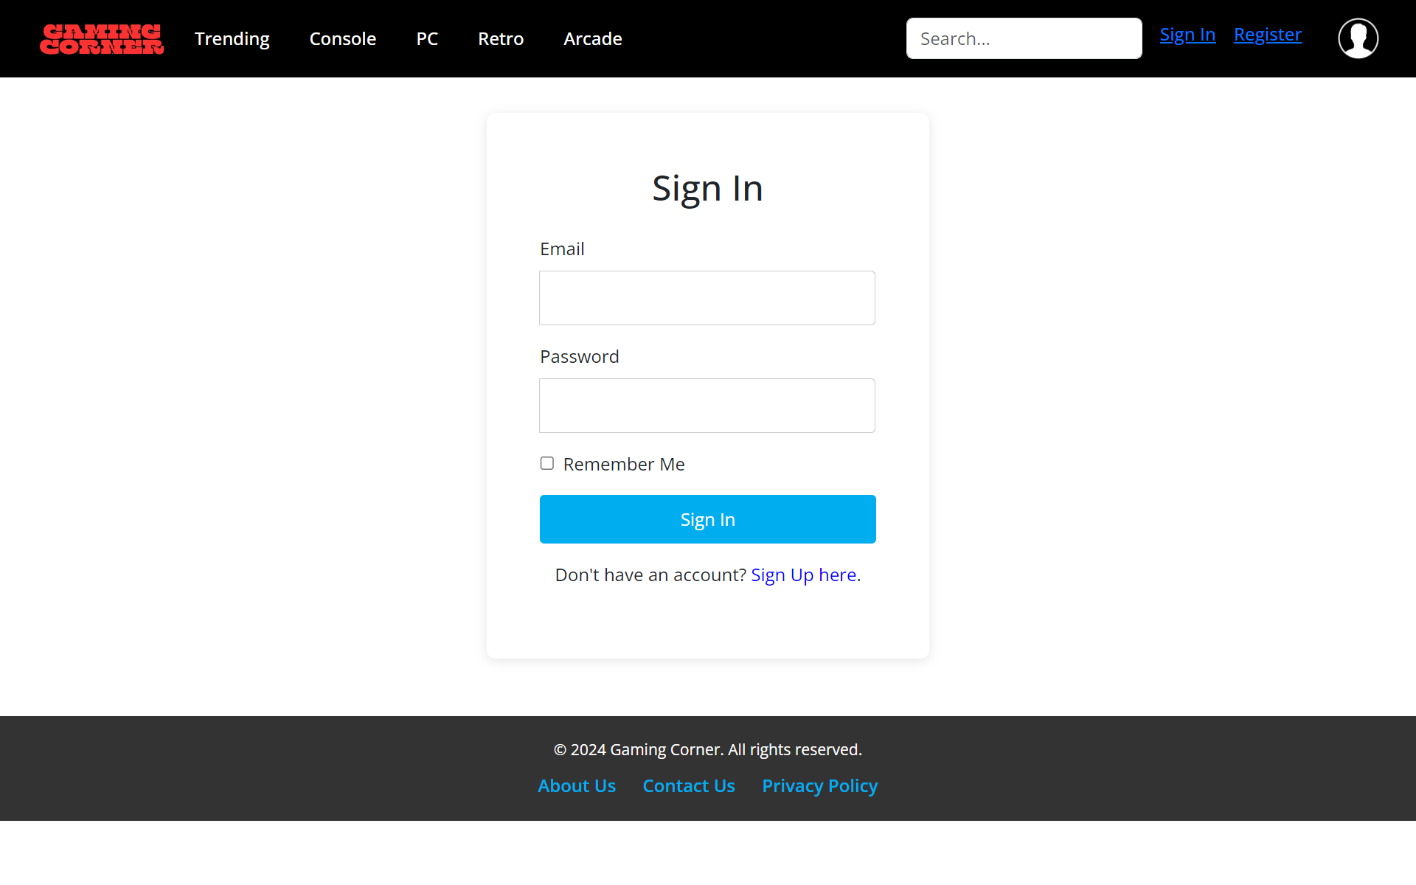

* **Sign Up Page**

In this page, we will input our data to sign up to the website so we could sign in later on to the website.

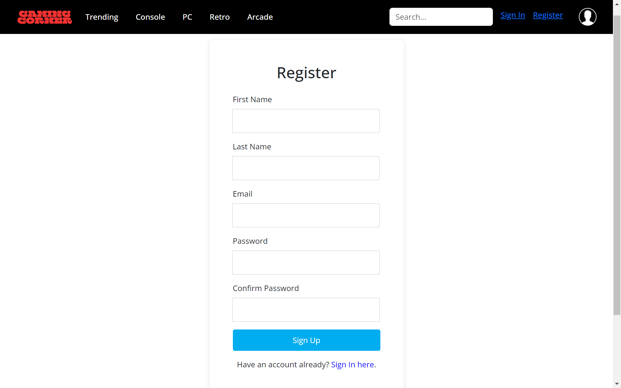

**WEBSITE PAGES (SIGN IN AND SIGN UP)**

* **Profile Page**

In this page, we will see our own profile in this website. We can change the profile picture, names, email, bio, or password to our data.

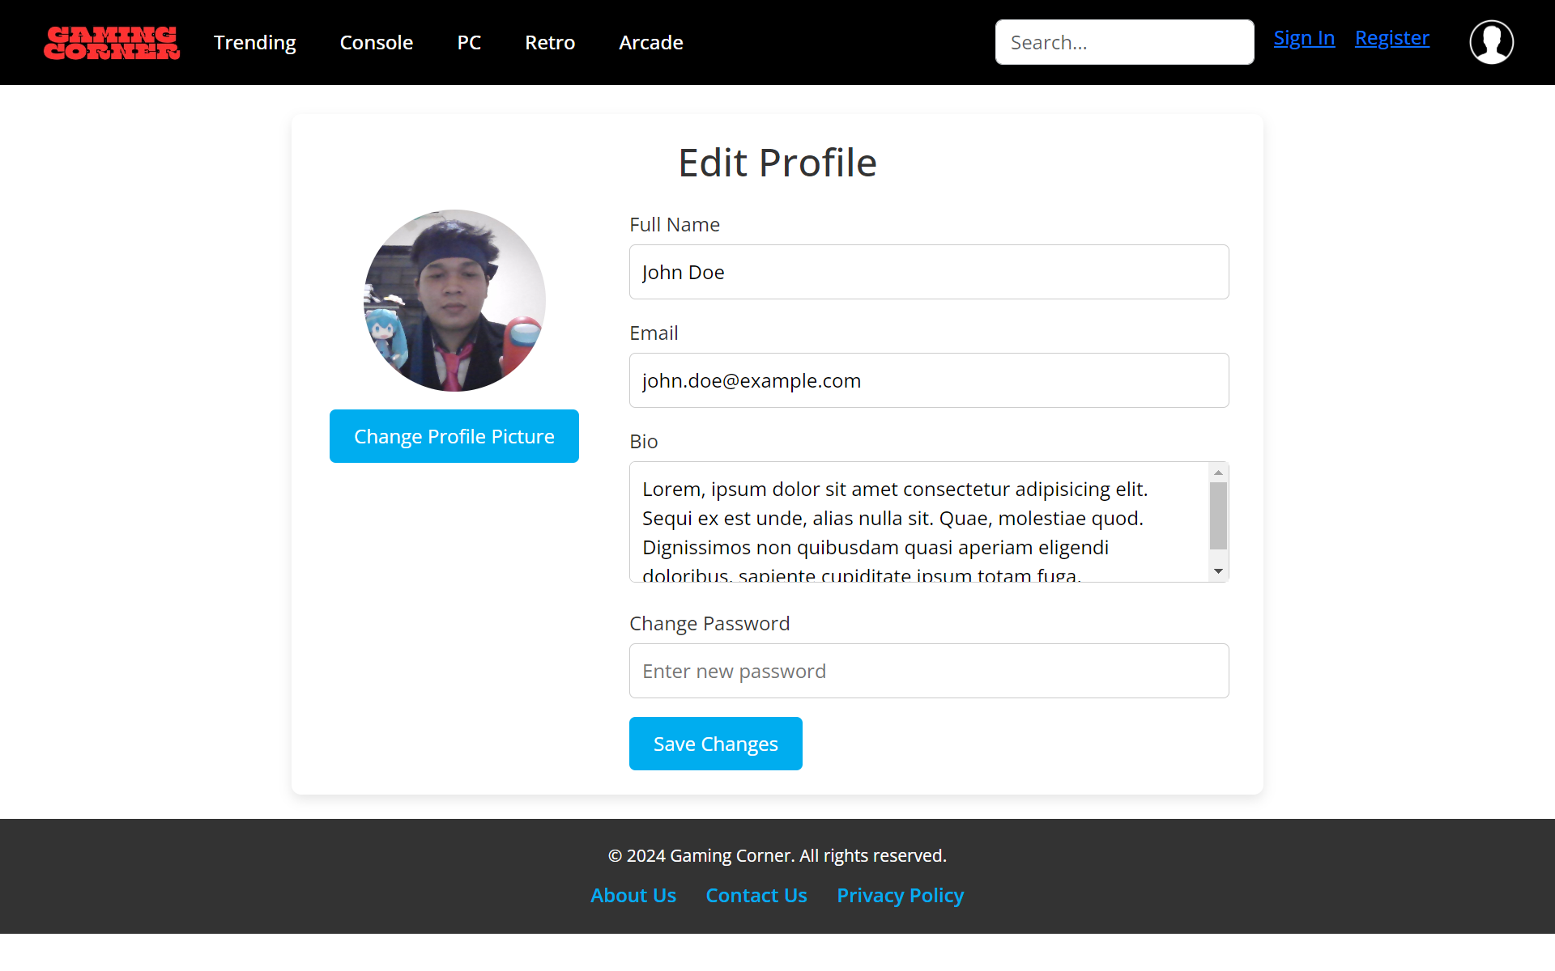

**WEBSITE PAGES (DATA PROFILE)**